Greetings!

I am writing to invite you to join the Federal Managers Association (FMA).

Founded in 1913, FMA is the oldest and largest professional federal management association. Dedicated to advocating excellence in public service, we represent managers and supervisors at all levels throughout the federal government. We actively fight for our members’ interests by working closely with the Executive and Legislative Branches of government.

FMA is a well-established, well-connected, and well-respected member of the federal community. FMA actively participates in the Government Managers Coalition (GMC), the Federal-Postal Coalition, the Public Employees Roundtable (PER), the Federal Employee Education and Assistance Fund (FEEA), and the Employee Thrift Advisory Council (ETAC), to name a few. FMA also maintains ongoing dialogue with the U.S. Office of Personnel Management (OPM) and the Office of Management and Budget (OMB).

Our government affairs personnel have strong relationships with key congressional staff and agency officials to ensure that FMA is closely involved in the policy development process. Through our allies on Capitol Hill, we fight for a fair and efficient approach to government and to ensure federal employees are not unduly burdened, especially during these difficult economic times. As a member, you will receive the monthly FMA Grassroots Update e-newsletter, advising you on our efforts and how you can help by writing your members of Congress, meeting with your leaders, and communicating your colleagues.

Our communications team keeps members informed about activities in the nation’s capital via FMA’s monthly e-newsletter, the Washington Report, and our website at www.fedmanagers.org. FMA also publishes The Federal Manager, a quarterly e-magazine that is delivered to our members.

As you know there is strength in numbers, and we at FMA are looking for federal managers who bring enthusiasm and understand the importance of public service. We wholeheartedly invite you to become a member of the Federal Managers Association. With your help, our collective voice will be strengthened, while you will personally and professionally reap the many valuable benefits FMA offers. We continually strive to provide forceful, effective advocacy, valuable professional development, and money-saving benefits on insurance, legal consultation and financial planning, among other terrific discounts – all for the low rate of $150 a year for members-at-large, or half that ($75) for retired members. You also have the option if you are retired from federal service to become a Retiree Life Member at a one-time payment of $250.

Please visit us at www.fedmanagers.org and click on “Join Now” at the top of the page, or call our National Office at (703) 683-8700 for more information. I look forward to welcoming you into the Federal Managers Association!

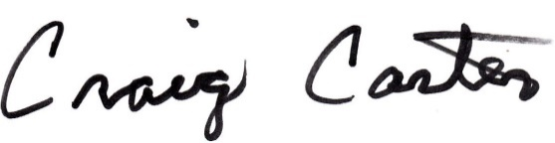
Sincerely yours,

Craig Carter
National President

