

FMA – YOUR ADVOCATE IN WASHINGTON
The Federal Managers Association is the foremost federal employee organization representing the interests of federal managers, supervisors, and executives in the federal government.
www.fedmanagers.org
Mission: Established in 1913, the Federal Managers Association advocates excellence in public service through effective management and professionalism, as well as the active representation of its members’ interests and concerns. FMA advances its mission through consultation with the Executive Branch and advocacy in Congress, top- notch professional development programs, informative publications, and networking opportunities for its members.


Membership: FMA is the largest and oldest federal employee organization representing the interests of managers and supervisors in the federal government today. Eligibility for regular membership extends to persons responsible for or associated with the management and supervision of people, programs, or projects. With more than forty different departments and agencies represented, FMA’s members span the federal government. Multiple membership options are available, including: at-large, chaptger, associate, retiree, and corporate.

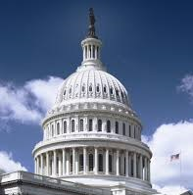
Advocacy: FMA engages in consultative relationships with top Executive Branch officials across the government. FMA also works with Congress on critical civil service issues. FMA’s track record includes legislative and regulatory success in federal pay and benefits, including a sick leave credit for FERS employees and the creation of disabled veteran leave; and federal management and hiring reforms, such as increased training initiatives. FMA’s issues agenda addresses preserving due process, competitive civil service pay and benefits, and maintaining the core values of the civil service. Advocacy efforts include congressional testimony, agency consultation, grassroots letter campaigns, and media relations. FMA is a member of the Employee Thrift Advisory Council (ETAC), which advises the Federal Retirement Thrift Investment Board on Thrift Savings Plan (TSP) matters, the Government Managers Coalition, the Federal-Postal Coalition, and the Federal Employee Education & Assistance Fund (FEEA) Board.
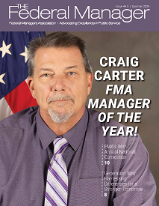
Publications and Information: FMA’s members receive exceptional publications and access to a wide range of important information. FMA publishes: The Federal Manager, a quarterly magazine focusing on federal managers and management issues; the Washington Report, a monthly e-newsletter detailing the latest developments on Capitol Hill and in the Executive Branch; the FMA Grassroots Update, a monthly e-newsletter assisting members with communicating with their members of Congress; annual Issue Briefs summarizing FMA’s policy positions; and, legislative action alerts assisting members with contacting members of Congress.


Meetings and Training: FMA sponsors an annual convention in Washington, D.C., regional meetings, and programs at the chapter level. Independent of internal conferences and training seminars, FMA also sponsors valuable professional development programs and workshops throughout the year.

1641 PRINCE STREET | ALEXANDRIA VA 22314-2818 | (703) 683-8700 | WWW.FEDMANAGERS.ORG

